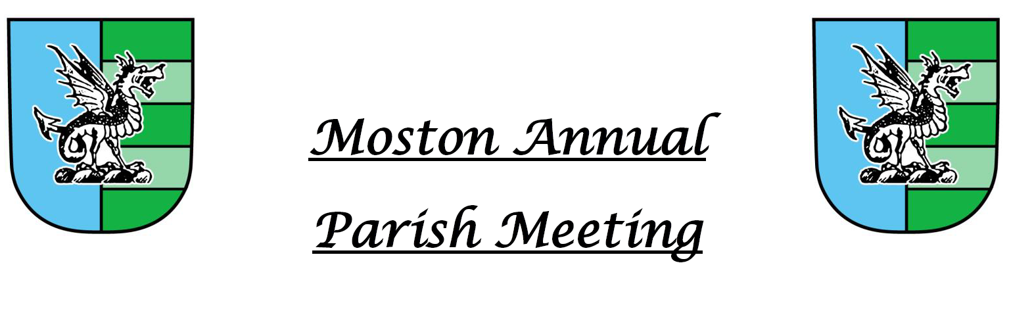
Minutes of the Meeting held on
Tuesday, 9th March 2022 At 7pm
at St Peters Church Hall

There were 12 members of the public in attendance

welcome from the parish chairman
The Chairman welcomed everybody in attendance

to approve the minutes of the 2021 Parish Meeting
The Minutes of the 2021 Annual Parish Meeting were approved as a correct record and signed by the Chair of the Parish Council

Matters arising from 2021 meeting
- Speeding was still an issue especially with Warmingham Lane closed. Cheshire East Council had attempted to introduce 30mph limit but no action was being taken at present
- Waiting approval from Cheshire East for developer to do the work.
- Walsingham planning – Section 106 Agreement – with Cheshire East solicitor

Moston in the Victorian Times
Mr John Pemberton presented an interesting insight as to how he would develop his Victorian History of Moston.

Suggestions for Moston Platinum Jubilee Celebrations
- Event on Moston Green where residents bring their own food.
- To consider the need for extra car parking
- Possible contribution to Albion Lock event

have your say
- Should push for Dragons Lane and Mill Lane to be resurfaced – system now needs individuals to report on fix my street .
- Once Warmingham Lane opened may be able to push for resurfacing

